Sara Nevedal
Tasha Candela
Career Field Experience
November 30, 2016
Paslin
“He who would learn to fly one day must first learn to stand and walk and run and climb and dance; one cannot fly into flying” (Friedrich Nietzsche). This quote applies to my placement because I started knowing hardly anything and I’m constantly learning more and more. In my Career Field Experience class I was a Processing and System Layout Co-op. In my opinion Career Field Experience is a unique class because it gave me the chance to have a hands on look at an engineering career. For thirteen weeks, I have learned more than I could have in a whole year in a normal classroom. While reflecting on my overall learning experience in this class, I will outline the three employability skills of ability to learn, a positive attitude, and teamwork and how I have grown as a professional.
One skill that is important to have is ability to learn. This means that no matter how much experience someone has they have to have an open mind about new skills. This is really applicable to engineering because there is always something new to learn. I have to have this skill because going in I knew virtually nothing so I’ve been taught a lot. Almost everyday I learn something new. This can also apply to being open about asking question, I also have to do this a lot because it would be hard for my supervisors to show me how to do everything before I have to do it. I believe that sometimes I learn more from asking questions then I do when I first being taught.
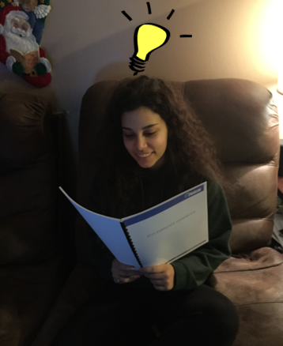
Another important skill to have is having a positive attitude and motivation. It is important to come into work everyday excited to be there. A worker can get a lot more work done if they want to do it. The work will also be a better quality. I try to come to work with a positive attitude everyday because I know that it spreads. Being positive not only helps me to be a better worker but everyone around me.
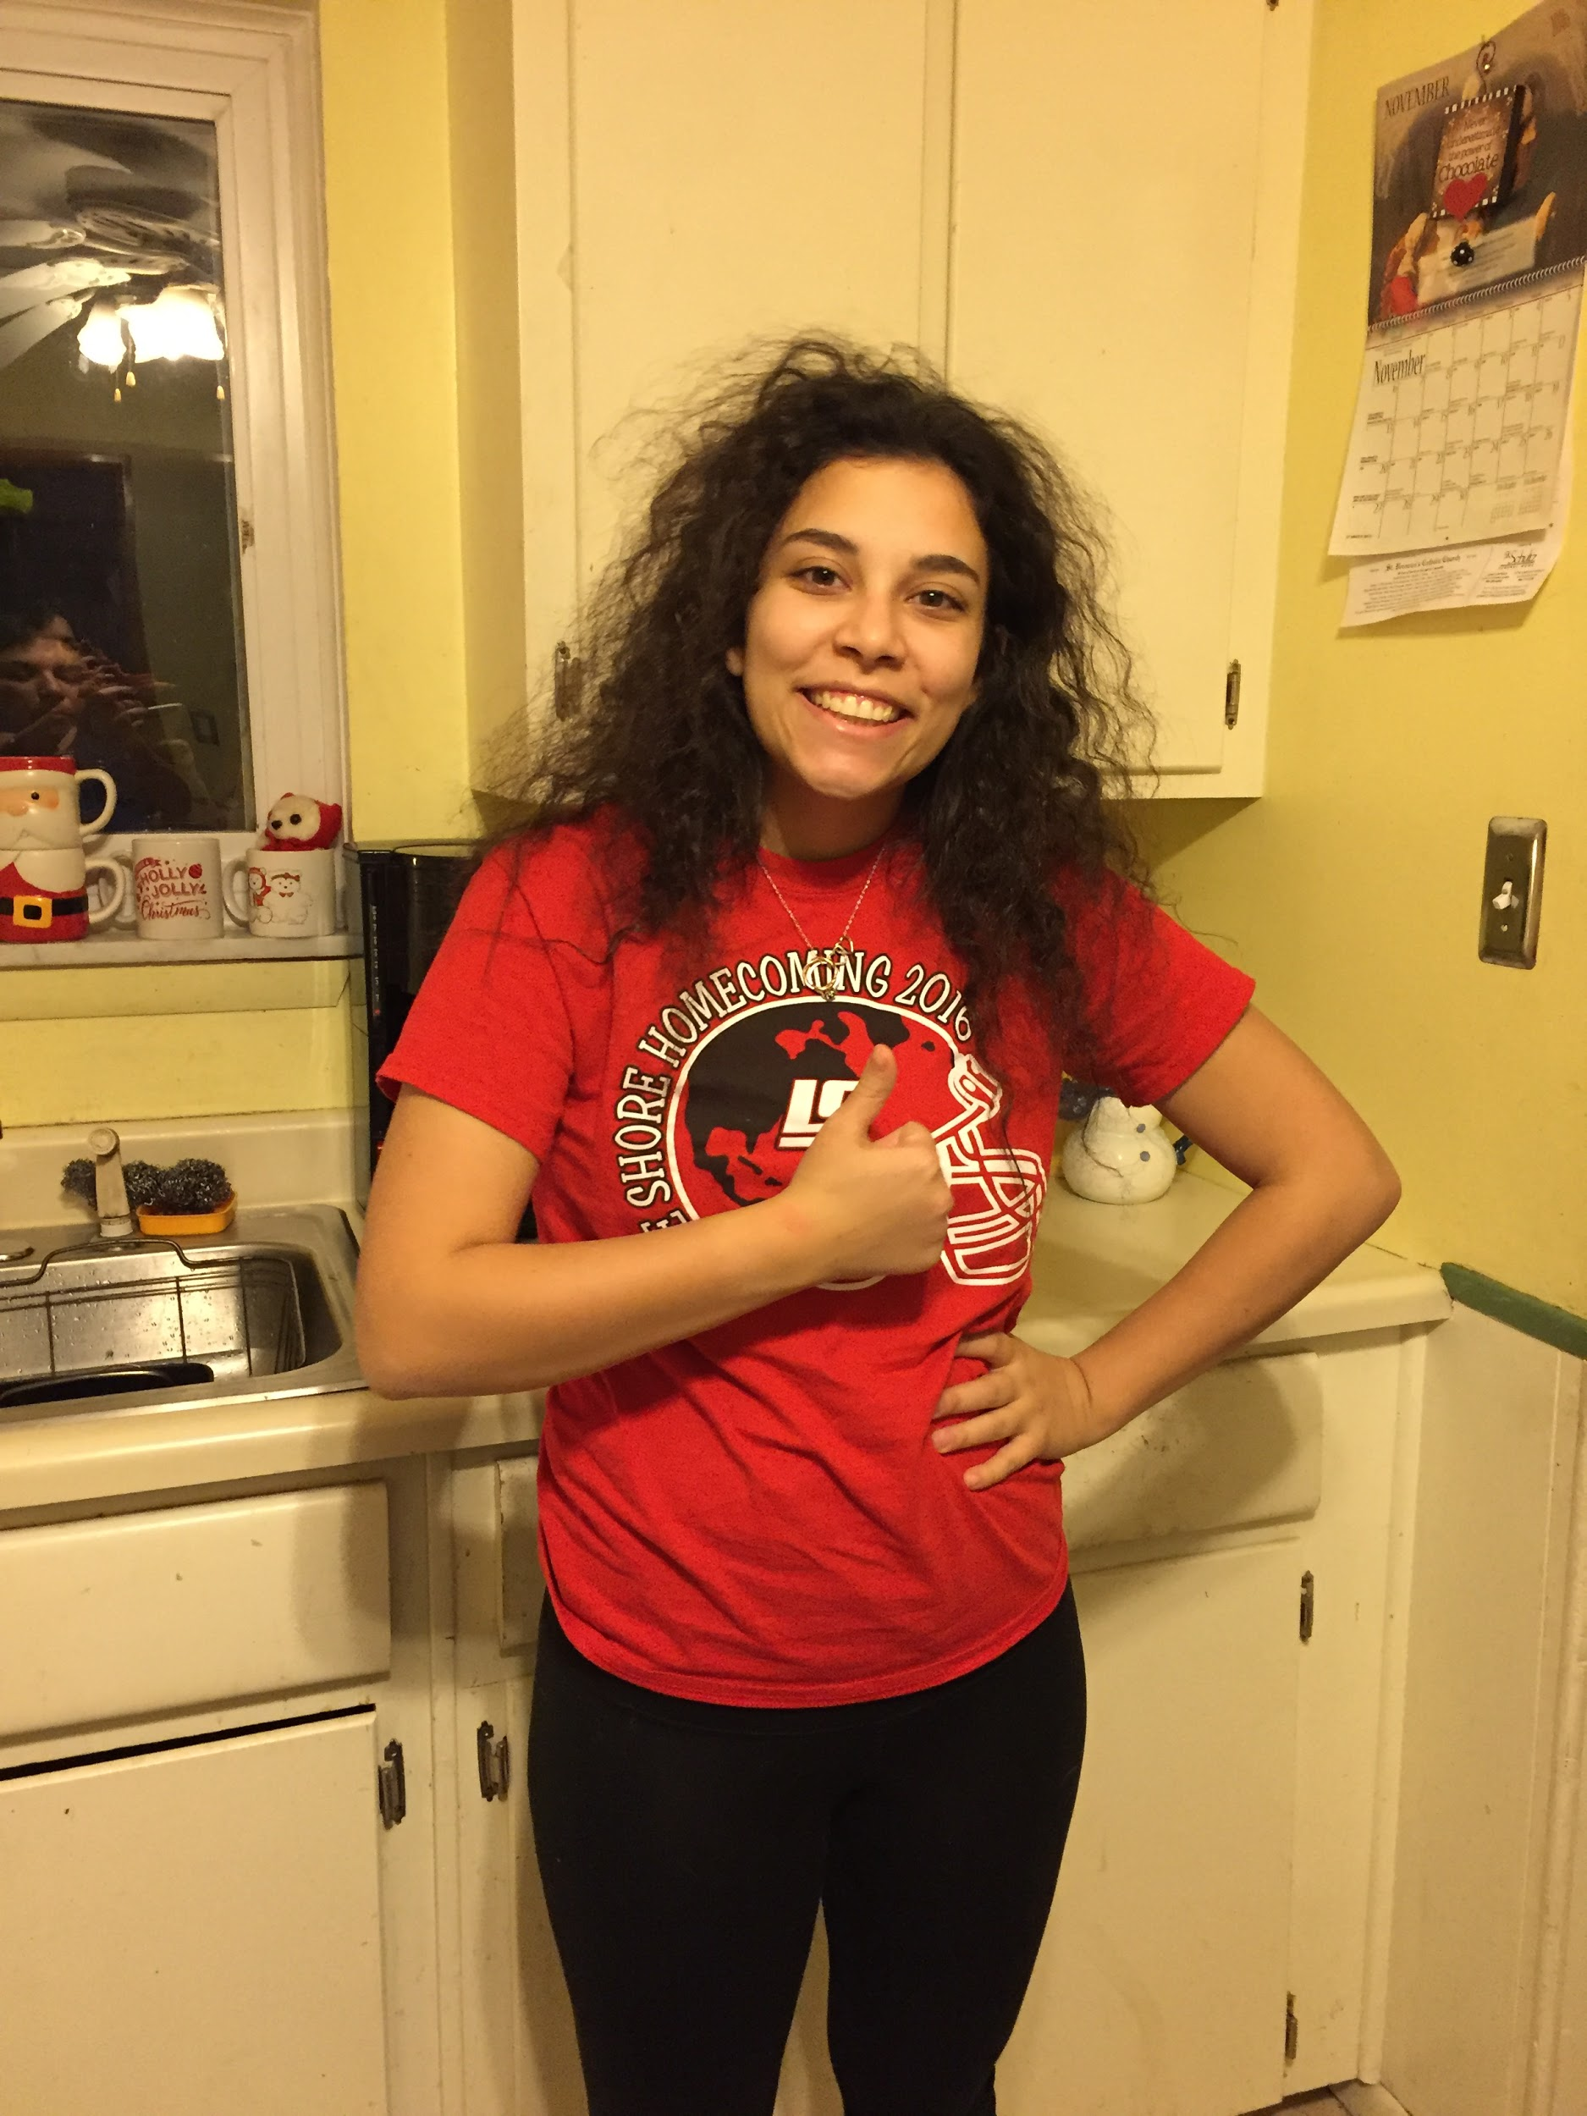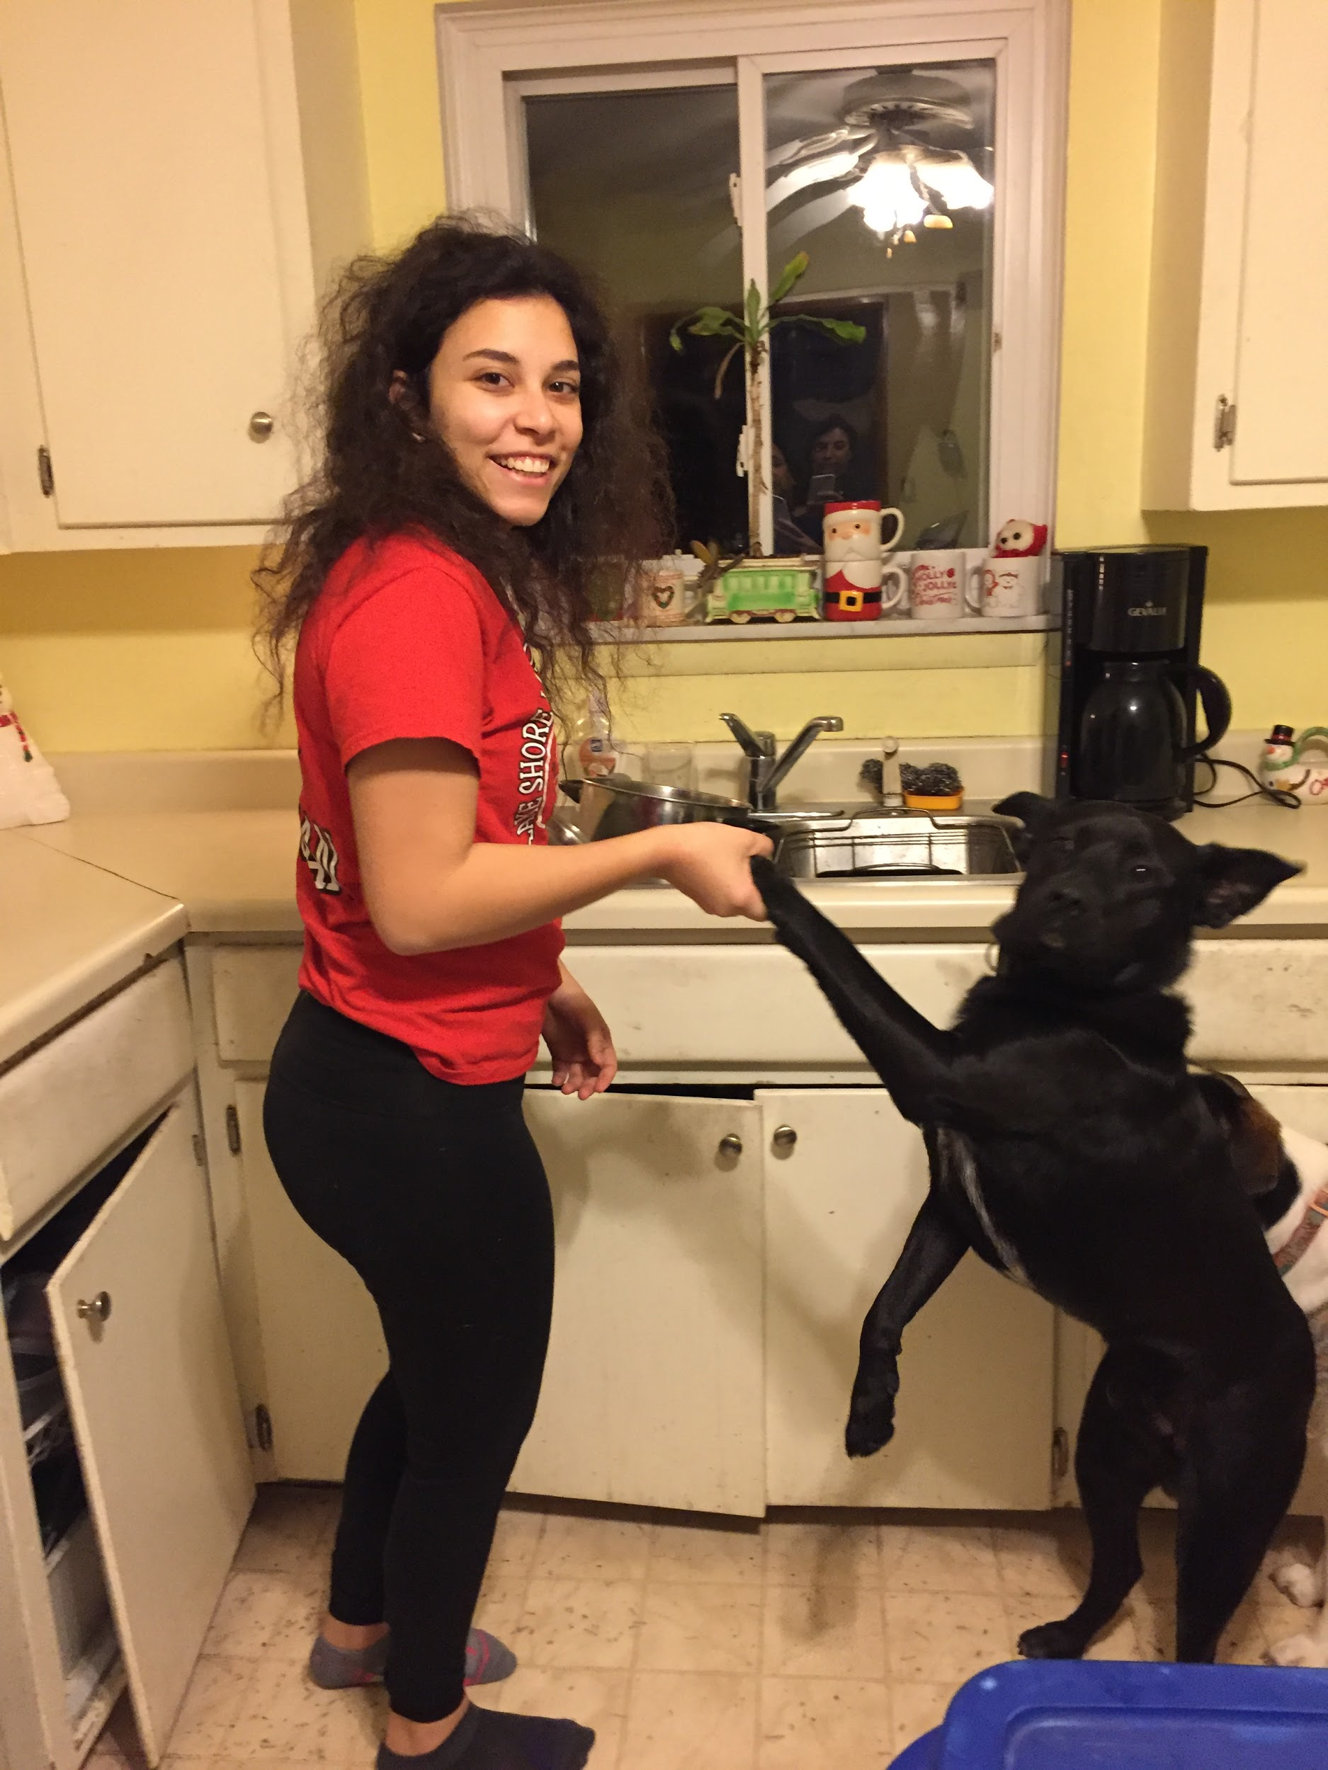
Teamwork is also an important skill. In a work place everyone needs to be able to work together. A good worker can work with their co-workers even if they don’t like the other person. This is especially important for engineering because everything is done as a team. At Paslin we have to all work together in order to make an assembly line that works. There is so much that goes into making an assembly that it takes many people to do it. Everyone needs to be able to work together because we are always working off each other's work.

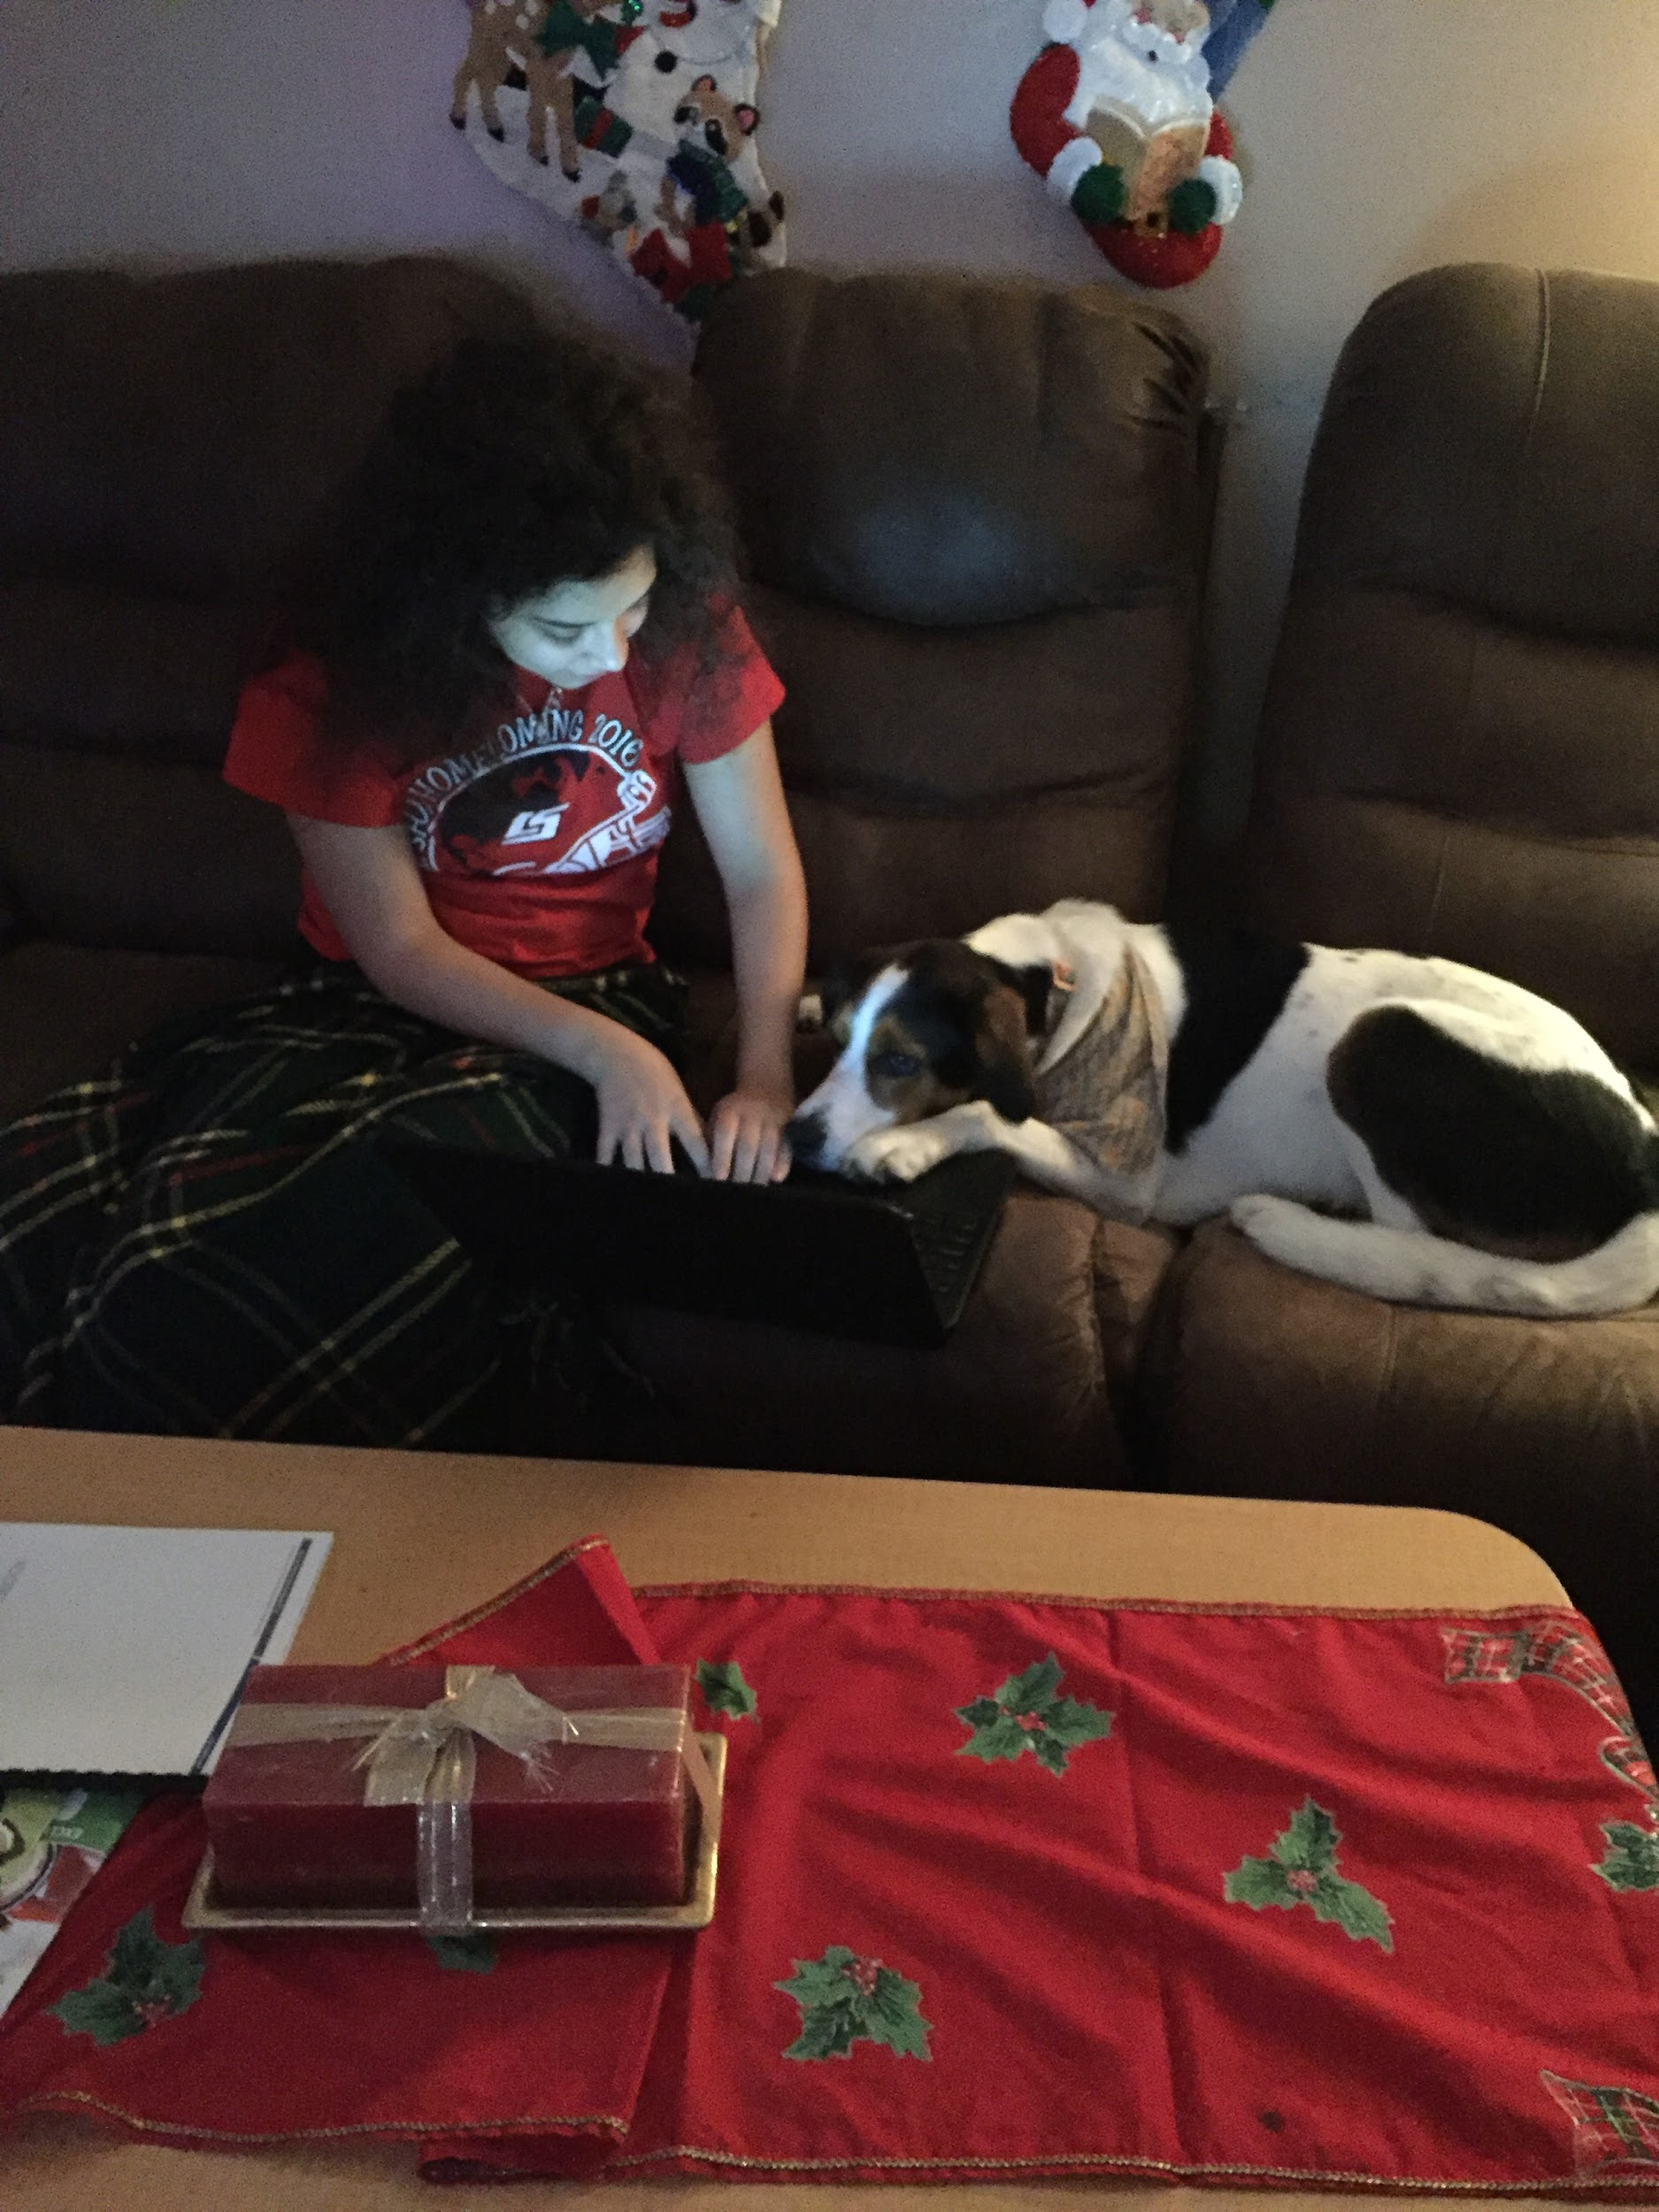

After reviewing my final evaluation and reflecting on my thirteen weeks of work I have found out my strengths and weaknesses. Something that I have improved on a lot since I started is completing my work in a timely manner, I have learned to focus on my work more that I can finish it. I also have a better understanding of what I’m doing now so it takes me less time to do my work. Something that I still need to improve on is my written communication. I still struggle when I have to write notes because I don’t know all of the vocabulary of what I’m doing so it’s hard to write about it. I can usually write so that I understand but I know it would be hard for my co-workers to understand it.
This class has changed me because it’s made me more professional. I know what it’s like to be in a real office now and how I have to be when I’m there, A moment that I will never forget is when I first used my computer at my own desk. I felt so grown up when I did this. I knew then that this was going to be a great class and opportunity. I would recommend this class to a friend because you learn stuff that you could never learn in a classroom. This class has really helped me prepare for the work force in a way that I never thought that I could in high school. My next step is to continue this class with two hours next trimester. This way I have more time to devote to my co-op and learning about engineering.

